**OverTheWire Bandit - Level 2 to Level 3 Writeup**

**Introduction**: This writeup documents my experience solving Levels 2 to 3 of the OverTheWire Bandit challenge, a CTF-style game focused on learning about security concepts.

**Author**: Misha Jain

**Date**: October 19, 2023

**Tools Used:**

Terminal (SSH client)

**Challenge Description:**

Level 2 to Level 3 of Bandit involves connecting to a remote server via SSH and retrieving the flag located in the home directory of the server. These levels introduce more advanced shell commands.

**Enumeration:**

For Level 2, we need to connect to the server using the credentials we obtained in Level 1. This will reveal a password for Level 3.

**Exploitation - Level 2:**

To connect to the server for Level 2 using SSH, we use the provided credentials:

ssh bandit2@bandit.labs.overthewire.org -p 2220

Use the password obtained from Level 1, which is rRGizSaX8Mk1RTb1CNQoXTcYZWU6lgzi to gain access.

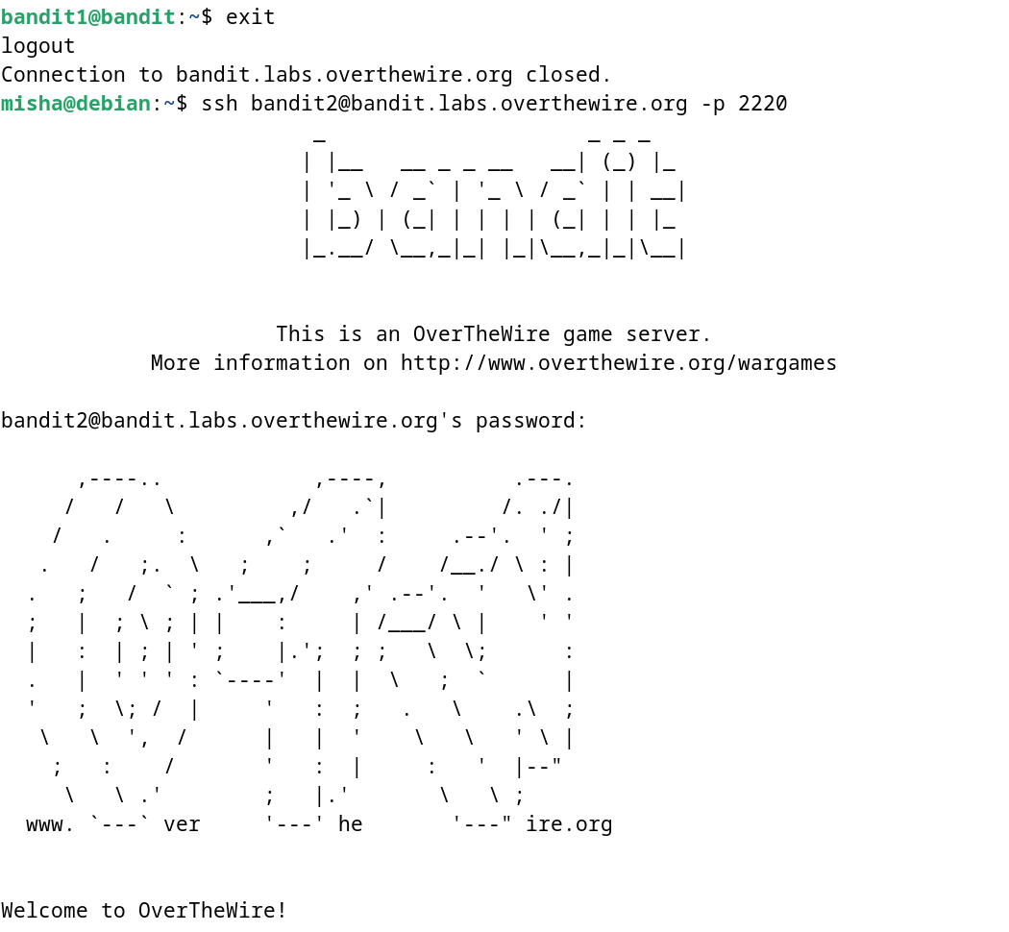

**Password Retrieval - Level 2:**

The password for Level 3 is stored in a file named ‘spaces in this filename’ in the home directory. We can use the cat command to read the contents of this file:

cat spaces\ in\ this\ filename

To display a file named ‘spaces in this filename’, we use the cat command along with backslashes to escape the spaces in the filename.

This command will display the Level 3 password.

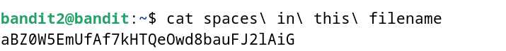

**Password – Level 3:**

The password for Level 3 is: aBZ0W5EmUfAf7kHTQeOwd8bauFJ2lAiG

**Exploitation – Level 3:**

Now that we have the Level 3 password, we can connect to the server for Level 3 using SSH:

ssh bandit3@bandit.labs.overthewire.org -p 2220

Use the Level 3 password to gain access.

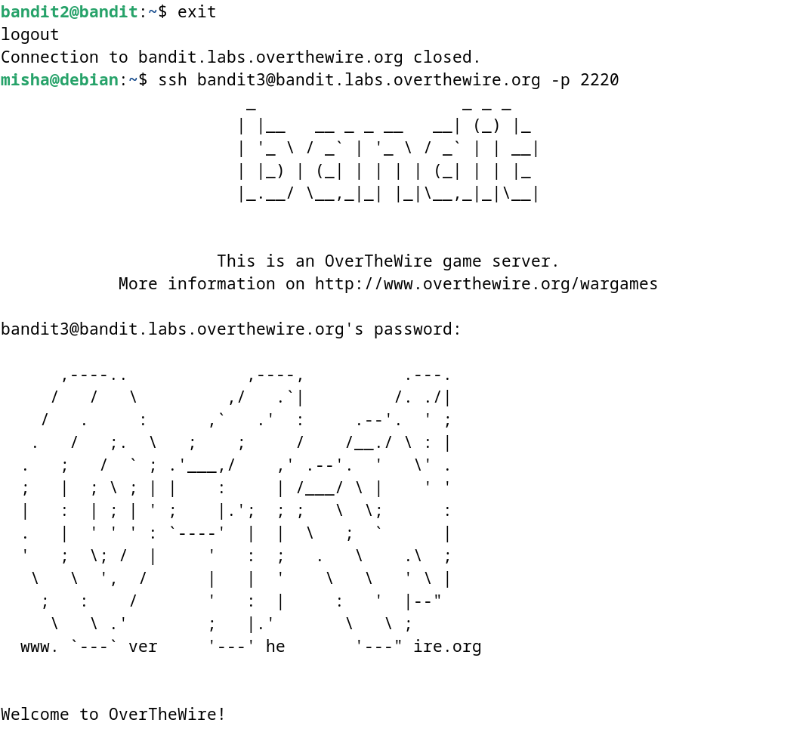

**Lessons Learned:** Level 2 to 3 introduced us to handling filenames that have spaces using the cat command.

**Conclusion:**

Levels 2 to 3 of the OverTheWire Bandit challenge continue to build on shell command knowledge while introducing new challenges. These levels are suitable for beginners to learn more about file manipulation and handling special filenames.